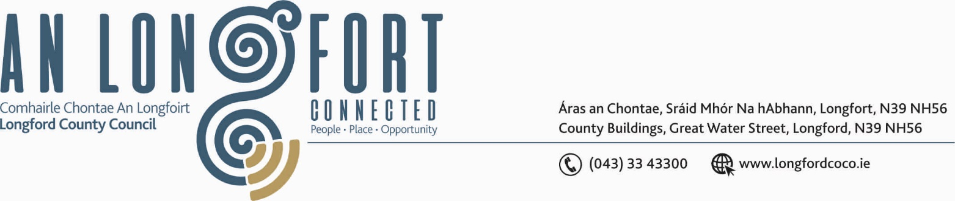

GRANARD MUNICIPAL DISTRICT

Corporate Affairs,
Aras an Chontae,
LONGFOIRT.

16th May 2018.

To: Each Member of Granard Municipal District.

Dear Member,

You are requested to attend Meeting of Granard Municipal District to be held in
Granard Community Library on Tuesday, 22nd May 2018 at 3.45 p.m. to transact business, as set out on the Agenda hereunder.

Yours sincerely,


_______________
Anne Lee,
Meetings Administrator.

AGENDA

Prayer before meeting.

1. Confirmation of the following Minutes of Granard Municipal District Meetings -
- Committee Meeting held on the 27th March 2018.
- Municipal District Meeting held on the 27th March 2018

2. Matters arising from Minutes.

3. Area Engineer’s Progress Report.

4. Notices of Motions submitted by Councillors, as listed hereunder. –

Councillor Pauric Brady.

“That the trees in the old Graveyard in Drumlish that have been uprooted and are leaning over headstones be cut and removed before they cause serious damage.”

“That the traffic lights in Drumlish be fixed as a matter of urgency as they are out of order for the past couple of weeks.”

Councillor Gerry Hagan.

“I call on Longford County Council to install traffic calming measures at Ennybegs Village.”

"I call on Longford County Council to carry out a Low Cost Safety Scheme on the R194 at Killeenatruhan in light of the numerous accidents which have occurred there over the years."

5. Correspondence - enclosed.

- To note letter dated 20th April 2018 received from the Department of Agriculture, Food and Marine regarding the Control of Noxious Weeds on Public Lands.
- Correspondence dated 25th April 2018 received from the Office of Public Works regarding site at the rear of Granard Garda Station.
- Correspondence dated 14th May 2018 received from Jim McKeon, Aughnacliffe regarding preservation works on the Dolmen in Aughnacliffe.

